CIS530 HW9: Submission Template

Text Simplification as Machine Translation

****NOTE: This template is here to guide you; you don't have to follow it to the T****

Problem 1.2: General Changes for Text Simplification (5 points)
Based on my experience manually simplifying complex sentences, here are five general changes that can be made to transform complex sentences into simpler ones:
- [Change 1]: [Describe a specific type of transformation you would make to simplify sentences. For example, you might discuss word choice, sentence structure, etc.]
Remove some unnecessary words from the sentence
For example:
Original sentence: The dramatic research and funding cuts and changes to skilled worker immigration policies threaten the greatest economic advantages as people powered innovation.
The simplified version is: "The research funding cut and change in immigration policies threaten the people powered innovation."
The word “dramatic”, and “skilled” are removed, because it doesn’t impact the main meaning of this sentence.
- [Change 2]: [Describe another type of transformation, different from the first one.]
Change the tone of the sentence
The Original sentence: There is little question that Alphabet has found itself in some trouble, largely because of antitrust scrutiny in the America and Europe.
The simplified version is: The antitrust in the America and Europe has caused the trouble for the Alphabet
The use of “antitrust” is changed. The tone of the sentence changed from passive to active.

- [Change 3]: [Describe a third type of transformation.]
Simplify the noun phrase
The Original sentence: One recent analysis from economists at University found that current and proposed cuts to federal research spending could whack the economy
The simplified version is: One analysis found that the coming research funding cuts could hurt the economy.
The noun phrase “current and proposed cuts to federal research spending” is replaced with “coming research funding cuts”. The simplified version helps reader to focus on the funding cuts, instead of “current and proposed”.
- [Change 4]: [Describe a fourth type of transformation.]
Remove less critical details from the complex sentence.
The Original sentence: Consumers and companies are relying increasingly on artificial intelligence as a source of information and as an internet entry point, challenging a search business that accounted for nearly half of its revenue in its latest quarter.
The simplified version is: Artificial intelligence is increasingly becoming an internet entry point that can impact nearly half of its revenue.
The part “Consumers and companies are relying on AI as a source of information” is removed. Instead, it focuses on the main idea that the AI is becoming an entry point.
- [Change 5]: [Describe a fifth type of transformation.]
Use the summarization method to simplify the sentence.
The Original sentence: The artificial intelligence company CoreWeave, which went public earlier this year, said the acquisition will help it verticalize its data center footprint, resulting in revenue growth and enhanced profitability.
The simplified version is: CoreWeave said the acquisition will help to grow the revenue.
This is an example to use summarization to simplify the sentence which focuses on the main idea on the acquisition will help to grow the revenue.
[Optional: You may include a brief explanation of why these changes make sentences simpler or more accessible to readers.]

Problem 6.1: Evaluation and Analysis (5 points)

Overall Performance Comparison
[Analyze the performance of your three systems based on your human evaluation results. Discuss which method performed best and provide specific observations about the quality of outputs.]
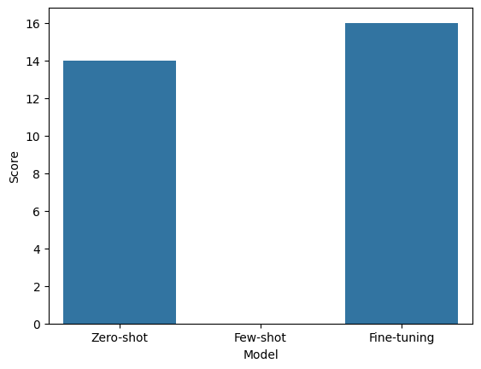
Based on chart, the fine-tuning has the best performance, 2nd comes as zero-shot. The few-shot model has the worst performance. But the performance between zero-shot and fine-tuning model are not much.

Zero-shot Performance
[Comment on how well the zero-shot prompting approach worked. Consider factors such as:
- Quality of simplifications
- Consistency across different sentence types
- Specific strengths or weaknesses you observed]
The quality of simplification is sometimes better than the fine tuning. For example, it can simplify “aid” to “help” where it picks a simpler word to express the same meaning.
But the consistency is not well, for the sentence: “Right now, I have no explanation, he said in an interview following the men's relay, in which he pinned the country's poor performance on slow skis.”, the zero-shot doesn’t simplify much.
The zero-shot model is good at picking simpler words to express the same meaning to replace a more complex word. But it’s weak in shorten the sentence overall.
The zero-shot model is also good at keep the original meaning during the simplification.

Few-shot Performance
[Comment on how well the few-shot prompting approach worked. Consider factors such as:
- Whether providing examples helped improve performance
- How well the model learned from your examples
- Any patterns you noticed in the outputs]
The quality of few-shot is poor. The model more like explain the meaning rather than simplify it.
Because the number of examples is small, and there’s no instructions what to do. The model cannot distinguish whether to simplify or putting an explanation. That’s why the performance is so poor.

Fine-tuning Performance
[Analyze your fine-tuned model's performance. Consider factors such as:
- Whether fine-tuning led to better results than prompting approaches
- Quality and consistency of the simplifications
- Whether the model learned the simplification patterns from the training data]

The performance is better comparing to the other two methods. Because the model is trained with more examples, it knows the concept of simplification not as summarization.
The pattern of simplification is consistent among all the examples, but the model is not good at using simpler word to replace the complex word.
Because the fine-tuning model is trained with the most simplified sentence, the model tends to over simplify the sentence a little too much.

Expected vs. Unexpected Results
[Discuss whether the results matched your expectations:
- Which approach you expected to work best and why
- Any surprising outcomes
- Possible explanations for unexpected results]
My expectation is the few-shot model will perform better than zero-shot model and the fine-tuning model will perform the best. Because the fine-tuning model has been trained with more examples than few-shot model and zero-shot model.
The result from few-shot model is surprisingly low.
For few-shot model, it’s only given with few examples, but the zero-shot model has been given the instructions on what to do. From this phenomenon, it shows providing an instruction has high impact to the performance.

Key Insights and Learnings
[Reflect on what you learned from this evaluation exercise:
- Insights about different approaches to text simplification
- Understanding of the strengths and limitations of each method
- Observations about the complexity of the text simplification task
- Any broader lessons about NLP model development and evaluation]

I learned how to use zero-shot, few-shot and fine-tuning model to do text simplification.
The zero-shot is good at picking simpler word to replace the more complex word.
The fine-tuning model is good at making the overall sentence shorter. But sometimes, the model failed to do any simplification or sometimes, the model simplified the sentence too much that the original meaning has changed.
For example:
Original sentence: Right now, I have no explanation, he said in an interview following the men's relay, in which he pinned the country's poor performance on slow skis.
Simplified by fine-tuning model: He said the country had poor skis.

Limitations and Future Improvements
[Optional: Discuss any limitations you observed in your evaluation process or the models themselves, and suggest potential improvements.]
When the sentence is already simple enough, even the fine-tuning model will not simplify it. Or the simplification is too much, and the simplified version has lost its original meaning.
The future improvements could be how to merge the instruction and the example together to get a new fine-tuned model to achieve better results.

Summary
[Provide a brief summary of your key findings and overall conclusions about the effectiveness of different approaches to text simplification.]
From this homework, the key findings are that the fine-tuned model can do a pretty good job in text simplification. But the zero-shot model with instruction can also achieve a pretty good results in simplification. When there’s no instructions given to the model, the number of training data need to be much bigger.

